Vpc task 2
1.Create one VPC, with 1 public subnet and 1 private subnet.
Go to AWS Console → VPC → Your VPCs → Create VPC
Select VPC only
Name: mytskvpc
IPv4 CIDR: 10.0.0.0/16
Click Create VPC

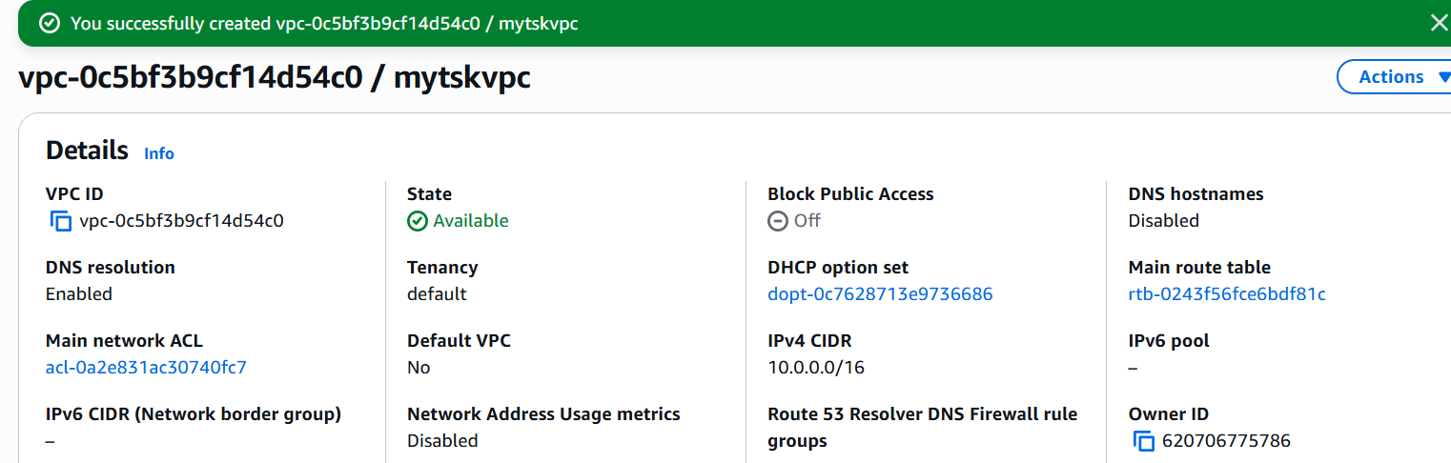
Create Public Subnet
- Go to Subnets → Create
- CIDR: 10.0.1.0/24
- Turn ON Auto-assign Public IP
Create Private Subnet
- Create another subnet
- CIDR: 10.0.2.0/24
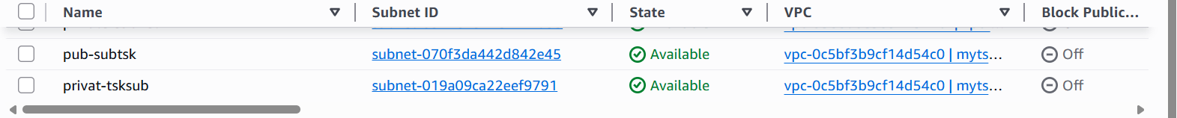

Enable VPC peering for cross-region.
Vpc in one region
Name – vpcvirigina
Vpc in another region
Name -vpcchoin
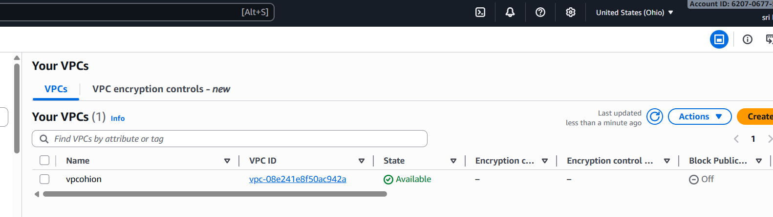

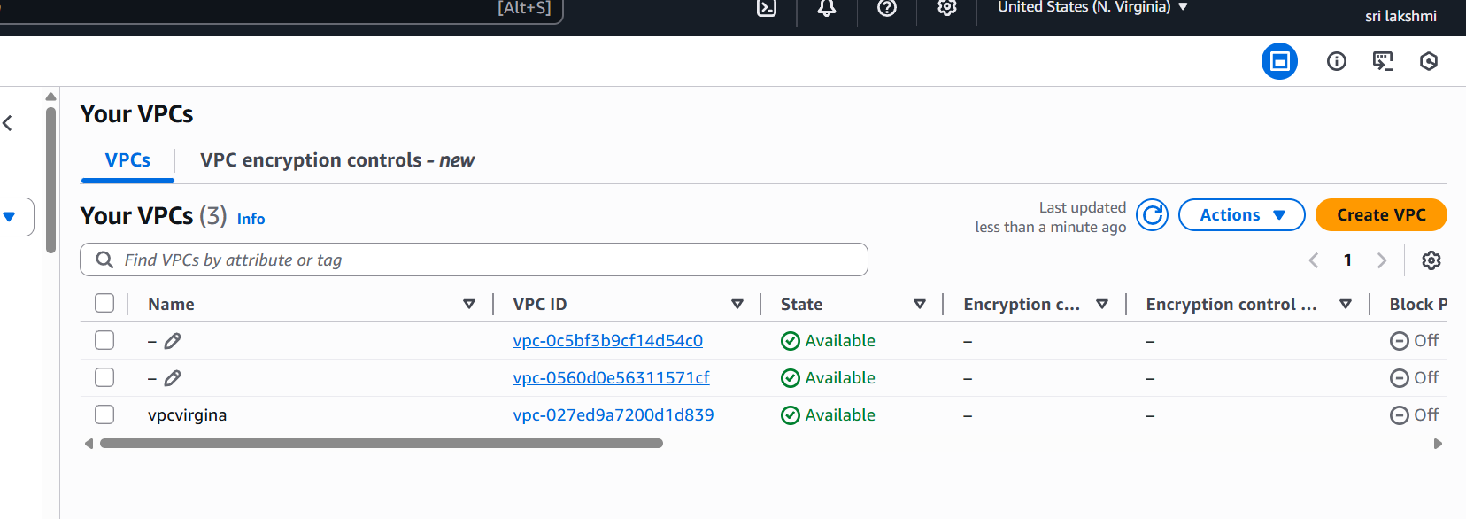
Go to VPC peering – create a peering connection
Name -peering vir -onio
Requester – vpc a (ap -south -1)
Accepeter – vpc (v=us -east-1)

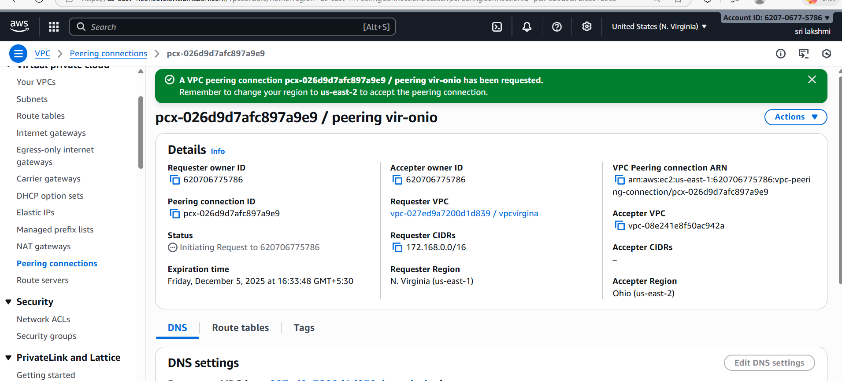

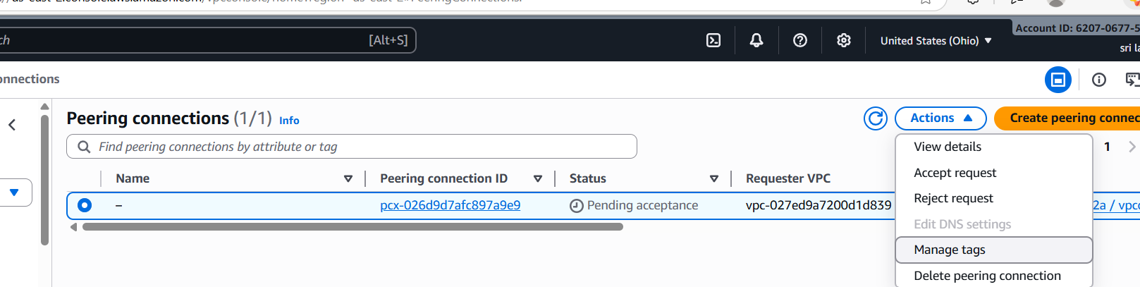
Go to vpc 2 – peering requests
Accept request
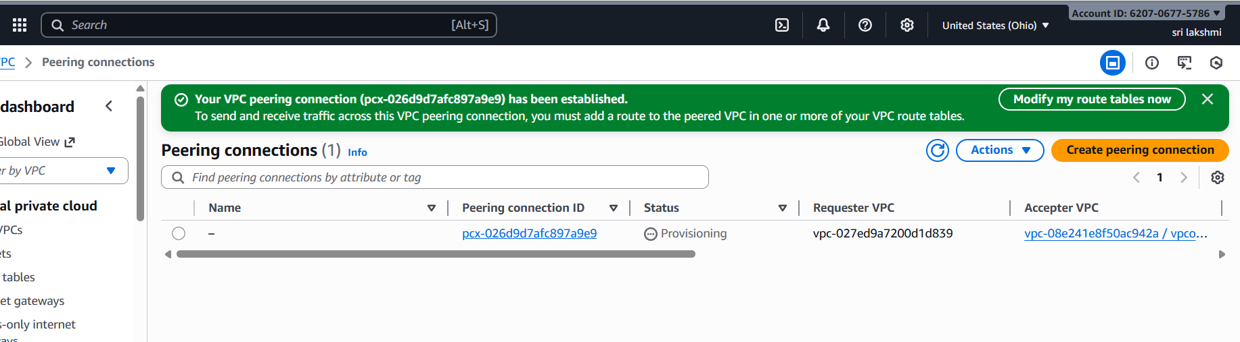

- Enable VPC peering for cross-account (you can collaborate with your friend to do this task).
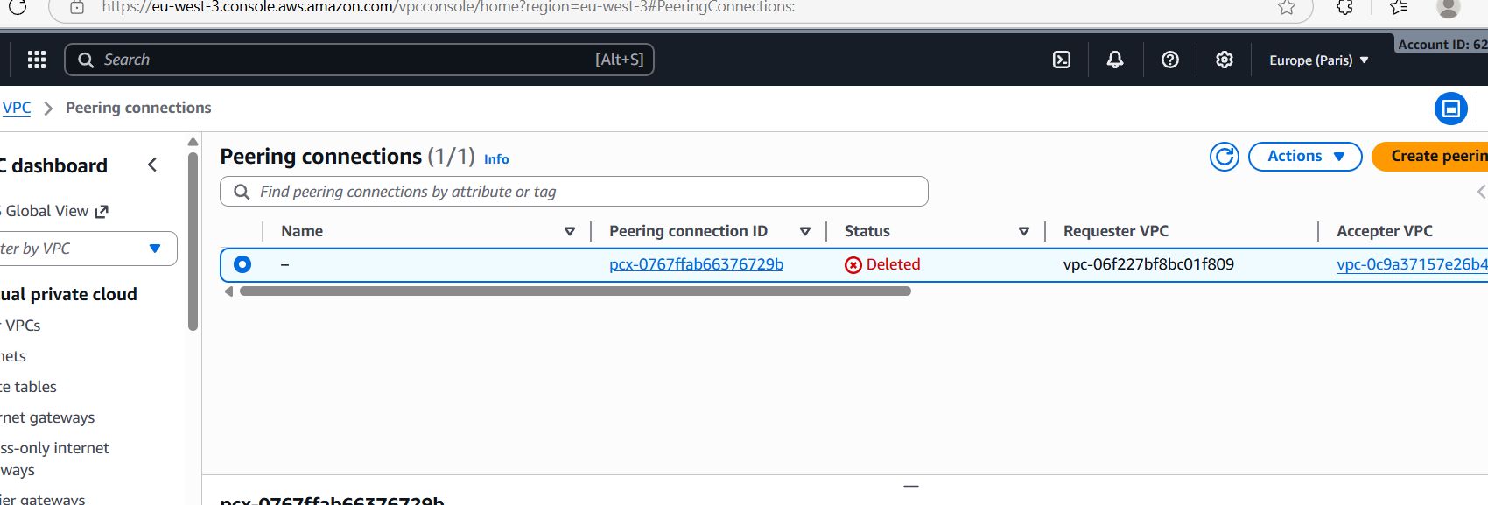
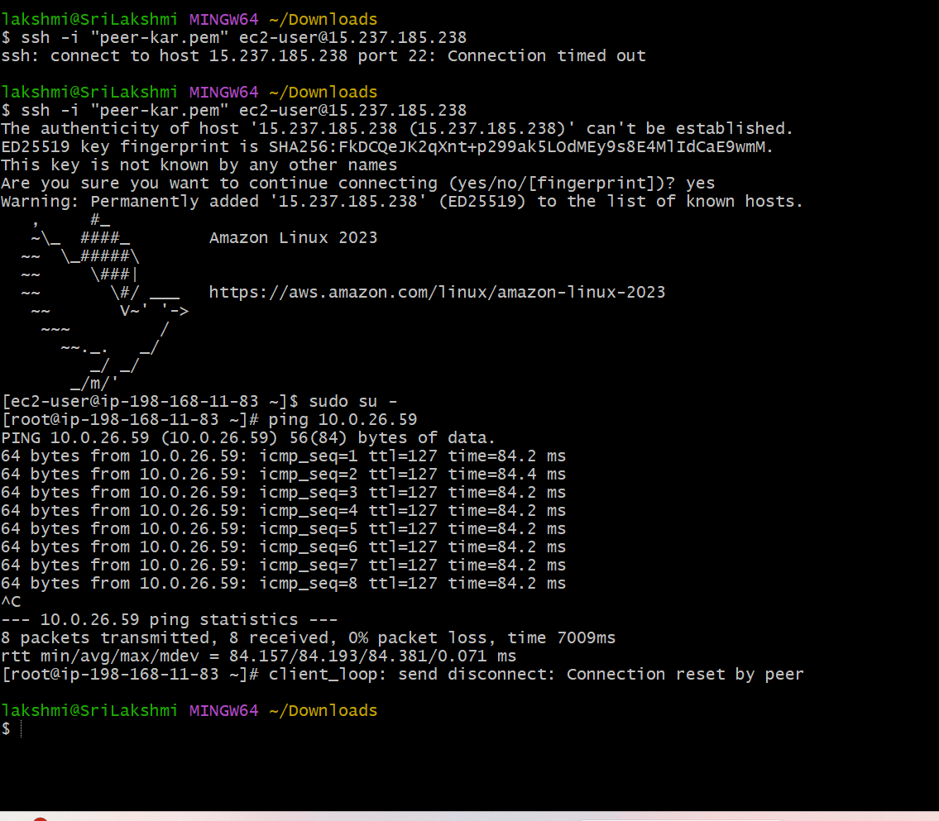

- Set up a VPC Transit Gateway.
Create a Transit Gateway
- Go to VPC Console
- Left menu → Transit Gateways
- Click Create transit gateway
- Give name → example: main-tgw
- Keep defaults → Create

Step 2 — Attach VPCs to the Transit Gateway
- Go to Transit Gateway Attachments
- Click Create attachment
- Select:
  - Transit Gateway → main-tgw
  - Attachment type → VPC
  - Choose VPC → Example vpc-production
- Select Subnets (one per AZ)
- Create attachment
- Repeat for all VPCs you want attached.

Step 3 — Update Route Tables
For each VPC route table:
- Open Route Tables
- Edit routes
- Add a new route:
- Destination: (other VPC CIDR)
- Target: Transit Gateway
- Save

Step 4 — (Optional) Connect On-Prem
Using VPN or Direct Connect, attach to Transit Gateway.

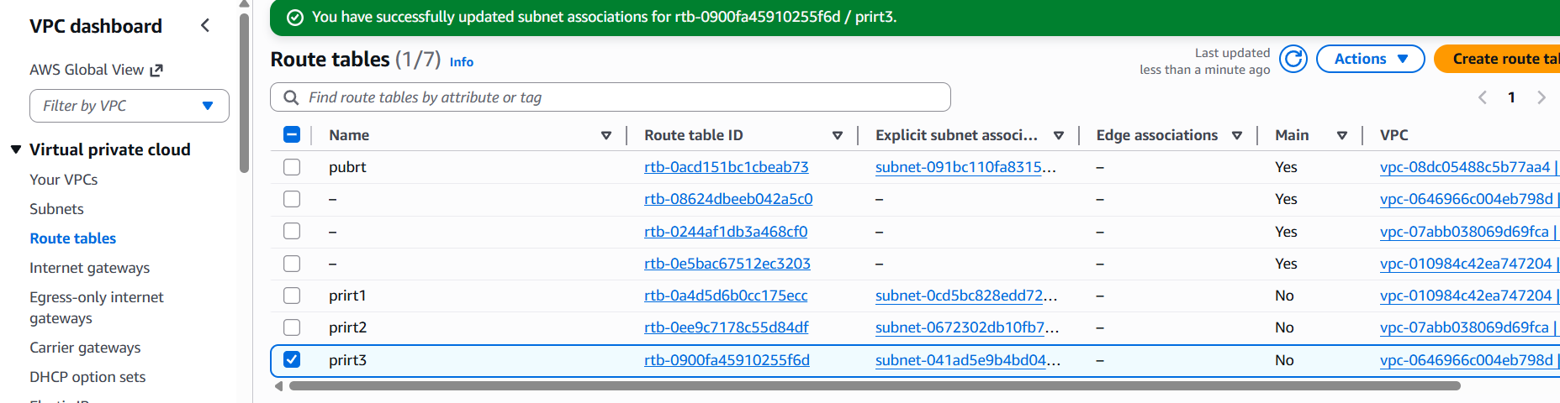
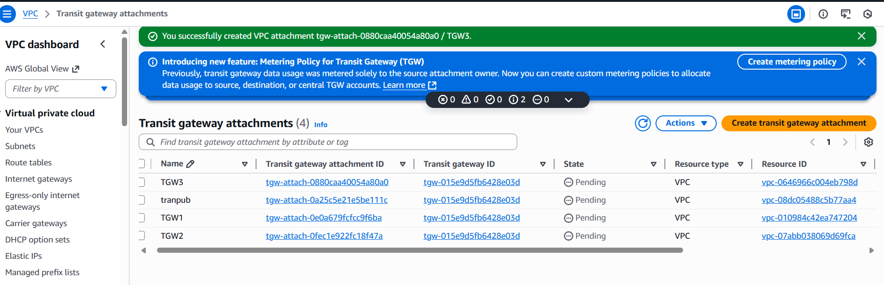
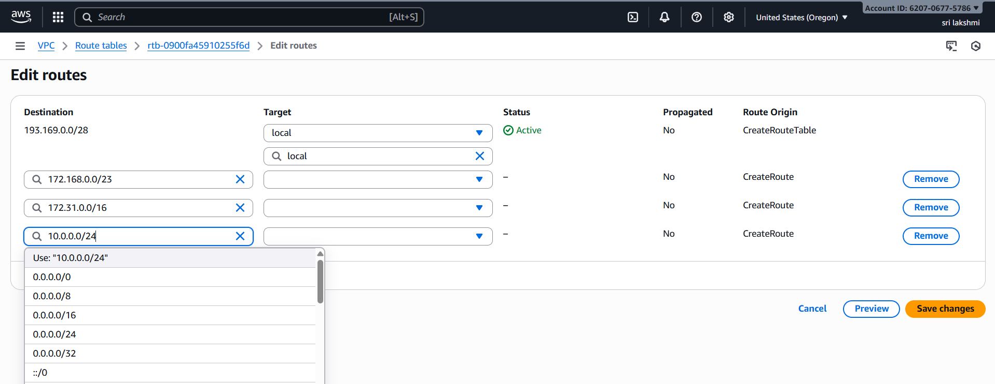
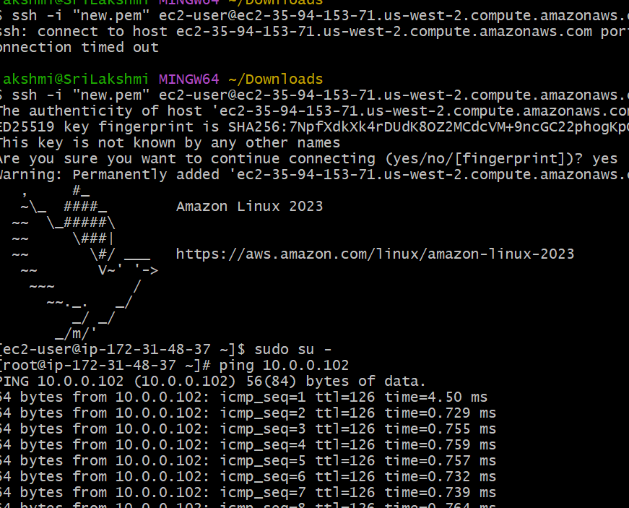
5.Set up a VPC Endpoint
Go to vpc-->create VPC
create internet gateway-->attach to created VPC
create 2 subnets public and private
create 2 route tables public and private
edit route table for public-->add route 0.0.0.0/0 target internet gateway
create 2 ec2 instances public and private one with public subnet and one with private subnetconnect to public ec2 insatance
Go to root sudo su -
aws configure
crate IAM user and generate key and password
give the access key and password, region and format
use command "aws s3 ls" to see the s3 logs
create a file and paste the pem key of public instance
Now login with private instance ip with in the same server
use command "aws s3 ls"-->command will not excuste because we have created any endpoint.Go to endpoint service create endpoint by selecting gteaway, adding s3-service-region, vpc and route table to private.check in CLI with "aws s3 ls" the s3 logs will be available.

